Bluetooth Beacon User Manual

# Introduction:

This user guide is meant to teach administrators of the SuperPoints (SP) app how to setup, configure and manage Bluetooth beacons in participating stores. This guide is written for Kontakt.io Bluetooth beacons and uses free resources provided by them.

# Resources:

To manage any Bluetooth beacons, you will need to have access to the SuperPoints Kontakt.io account to log onto the Kontakt.io website and phone app.

<https://panel.kontakt.io/signin>

<https://support.kontakt.io/hc/en-gb/articles/204805162-Get-familiar-with-the-Kontakt-io-Admin-App>

This manual only includes the basics on how to use to manage Bluetooth beacons, for more information visit Kontact.io’s support page: <https://support.kontakt.io/hc/en-gb>.

# Kontact.io Web:

The Kontact.io website is for broad management of your Bluetooth beacons. It allows adding beacons, setting locations to beacons for grouping, viewing data and statistics about your beacons, and setting configurations for them (note: you can configure the beacons but not modify the settings currently on them).

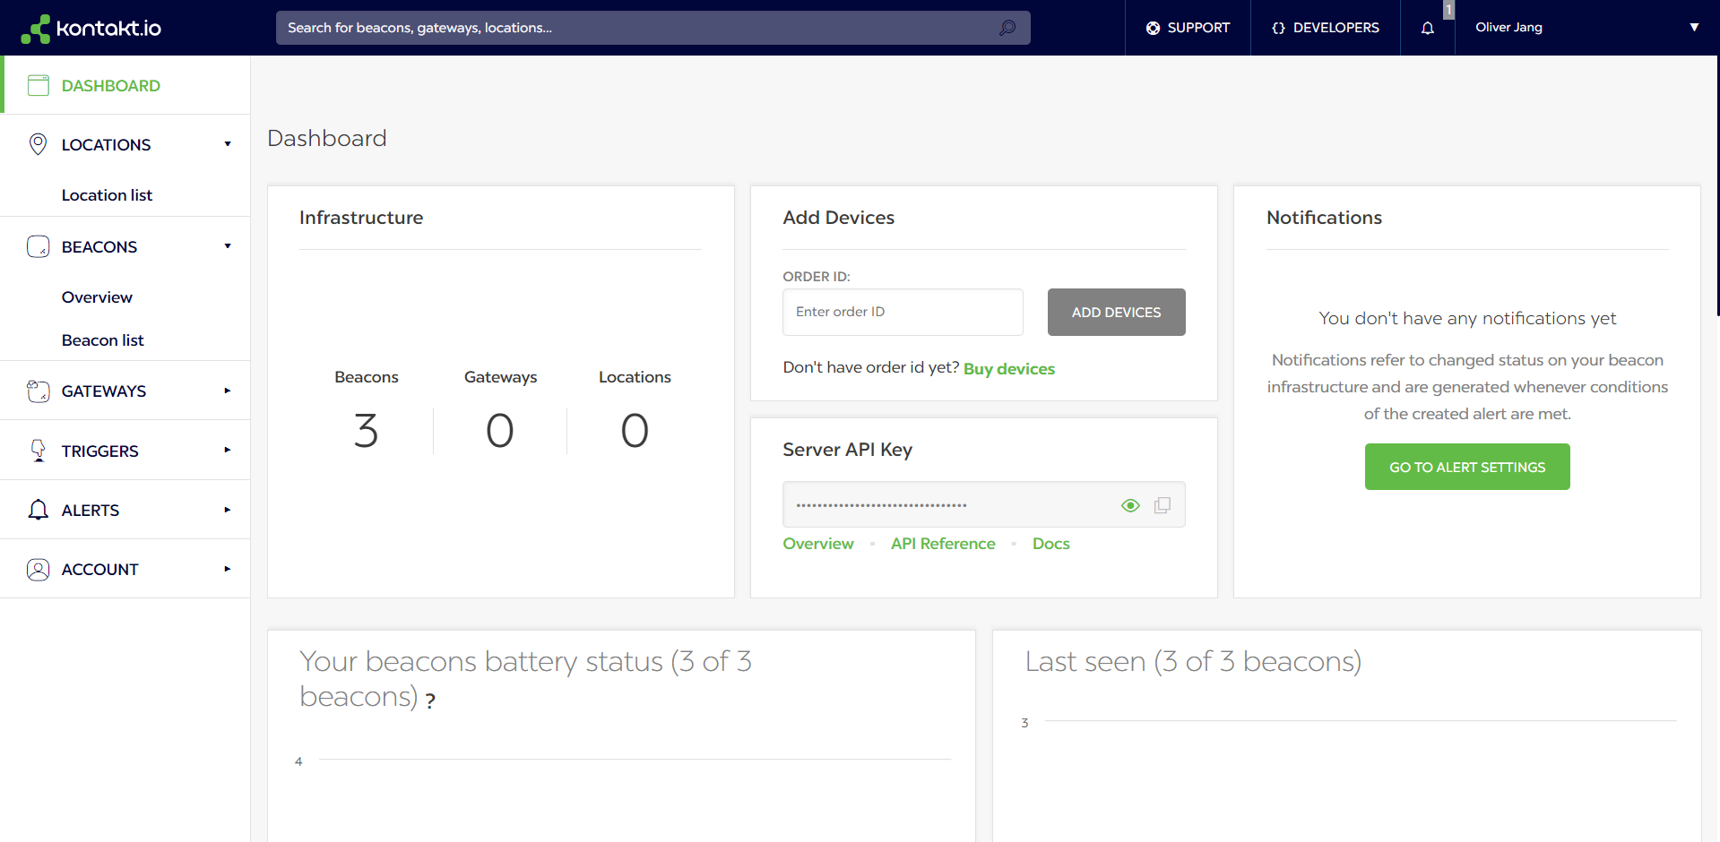

## Beacons:

The beacon page displays a list of all beacons attached to your account. On this page you can add new beacons, assign beacons, filter, and see general details on every beacon.

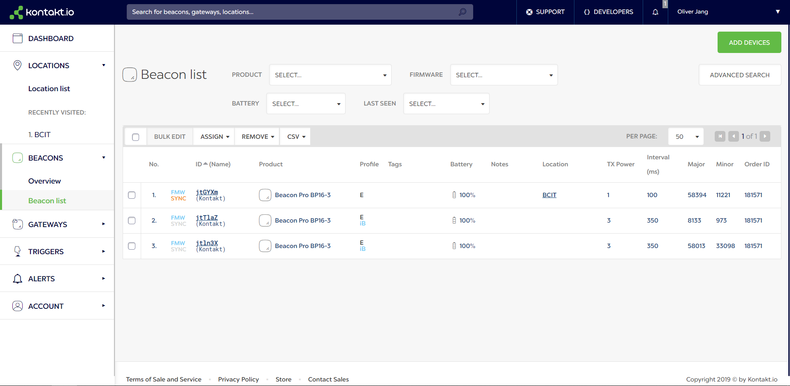

### Adding Beacons:

To add beacons to your account you will need to enter in your order ID. This ID should come with any order of Bluetooth beacons.

The order ID can be entered from either the main dashboard page.



Or by clicking ‘ADD DEVICES’ on the beacon page to navigate to the ‘Add Devices’ window.



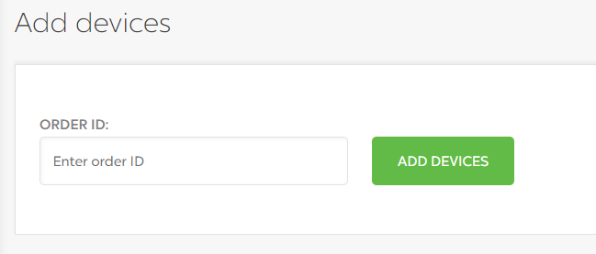

Once a valid order ID has been entered the beacons associated with it will be added to your account. They will be viewable through the beacons page.

### Configuring Beacons:

Any beacon in your account can be configured by clicking on the beacon name from the beacon page.



On the Beacon page there is a variety of settings that can be changed for the beacon. This guide will only be covering the basics:

* TX Power
* Interval
* UUID
* Major/Minor

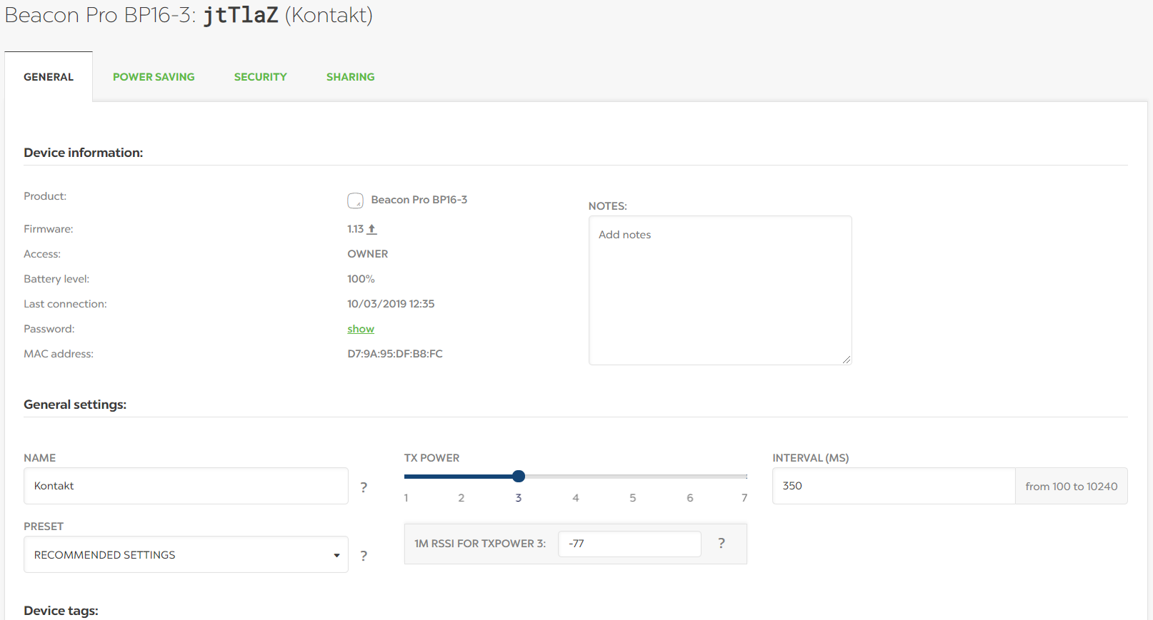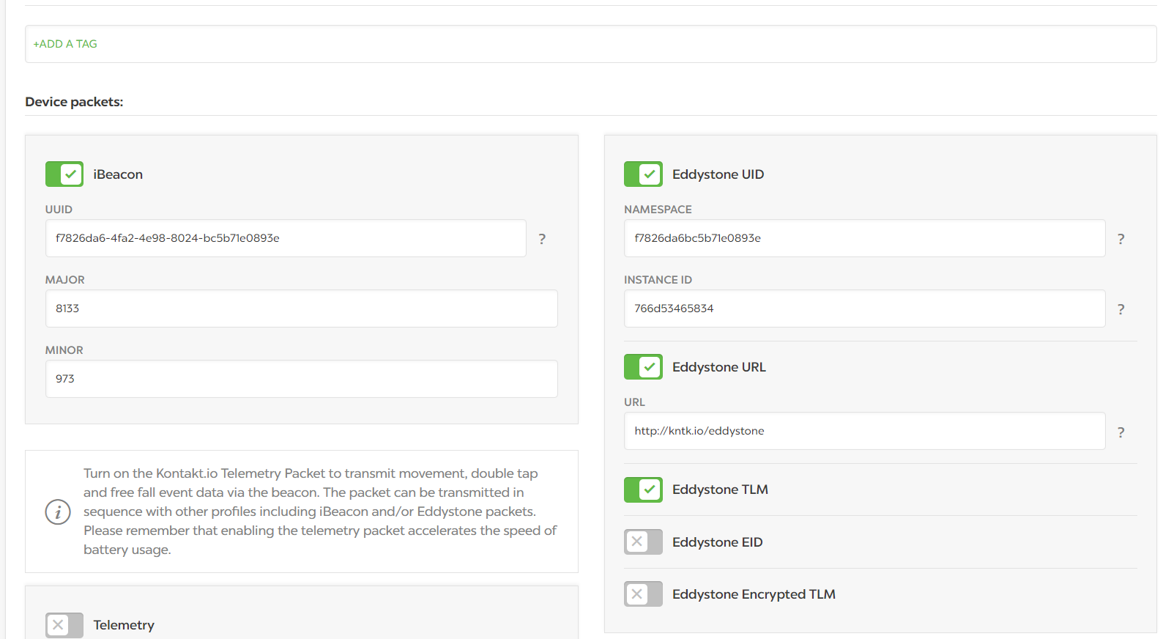

After any configuration click the ‘Save Changes’ button at the bottom of the page.

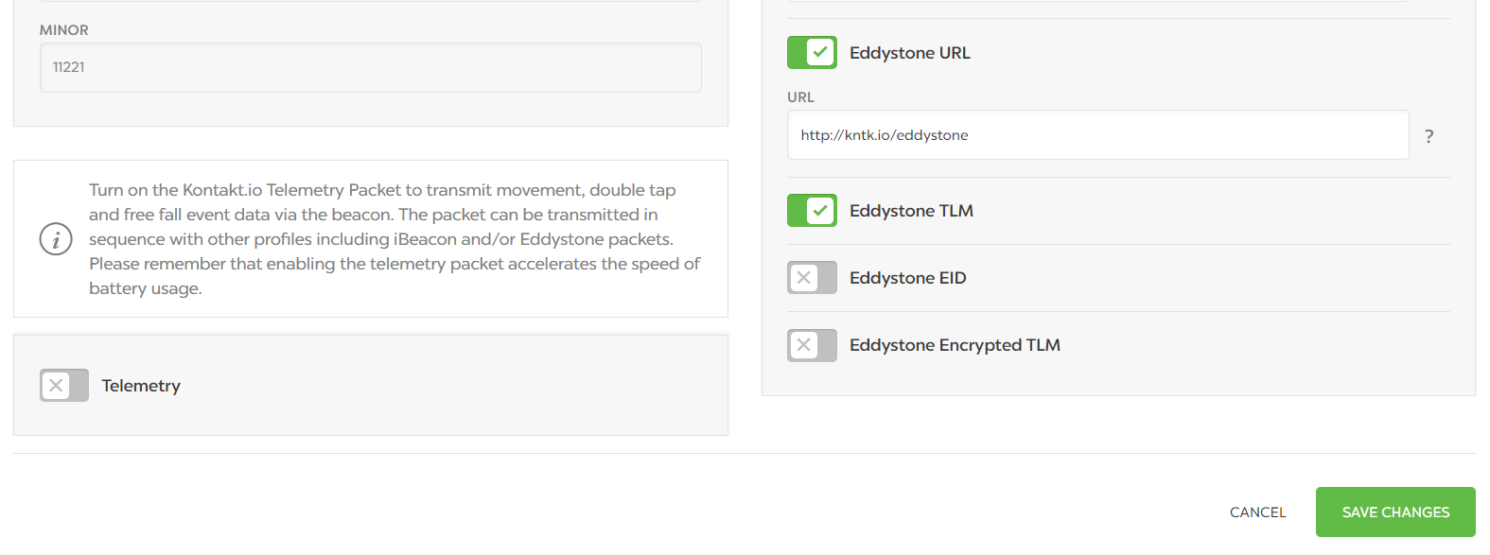

#### TX Power:

TX Power is the strength of the beacon signal. This field is the most important field for configuration as the strength of the signal determines how far away a device can connect to the beacon. The TX Power must be set to match the signal strength to the size of the store. Shoppers should only connect to the store once they are within it.



Approximate ranges of each TX Power level are listed in the below table. The range is a radius around the beacon’s position. As these ranges can vary greatly depending on the enviroment the beacon is in, it is essential to do testing with beacons to ensure the TX Power is correct.

Table from: <https://support.kontakt.io/hc/en-gb/articles/201621521-Transmission-power-Range-and-RSSI>

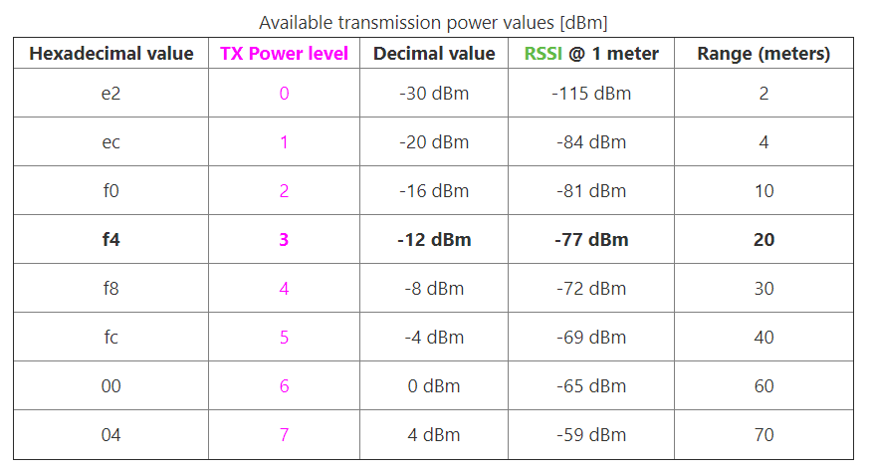

#### Interval:

The interval field specifies how often the beacon transmits its signal. The recommended interval by Apple for Bluetooth beacons is 100ms. Faster intervals will decrease battery life faster whereas slower intervals will increase battery life.

Table from: <https://kontakt.io/blog/beacon-configuration-strategy-guide-interval/>

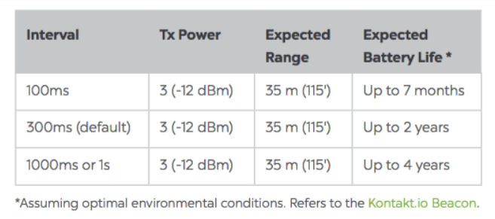

#### UUID:

The iBeacon UUID is the field that is used to link businesses to their beacons. The UUID is the same as the region, all beacons with the same UUID are in the same region. The value in this field should be unique to each business and needs to match the value entered for the business through the App Administrator account in the SuperPoints App. It is recommended to generate each UUID randomly, resources like <https://openuuid.net/> can help with this.



#### Major/Minor:

The Major and Minor fields for a beacon are used for unique identiciation within a region. These fields do not need to be set as the SuperPoints application does not use them.



## Locations:

Locations are used to group beacons together to make them easier to manage. The location grouping through Kontakt.io has no effect on the SuperPoints app or the associated database, it is only for managing beacons through Kontakt.io.

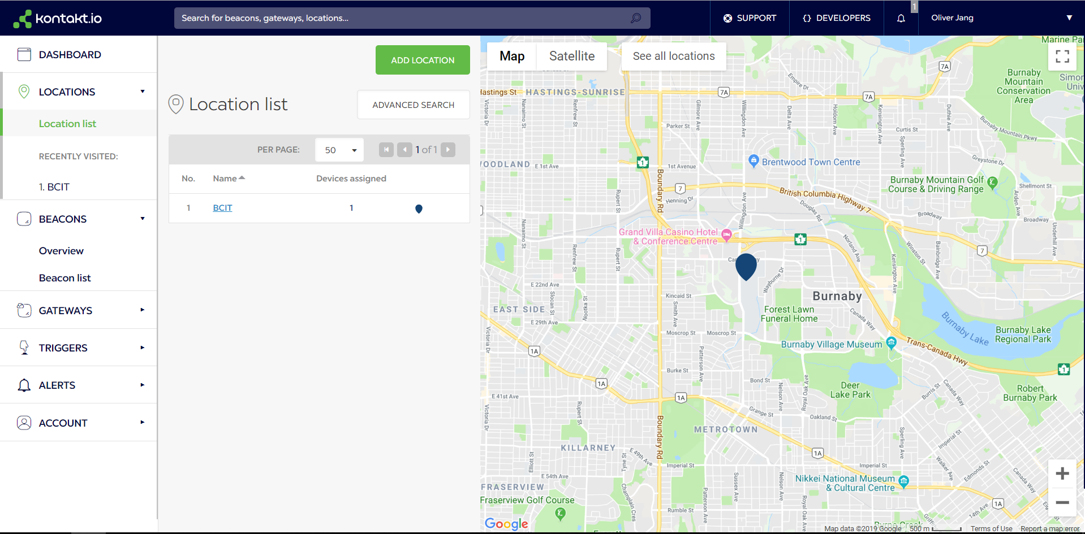

### Adding a Location:

Adding a location is done from the location tab by clicking on the ‘Create Location’ or Add Location’ buttons.



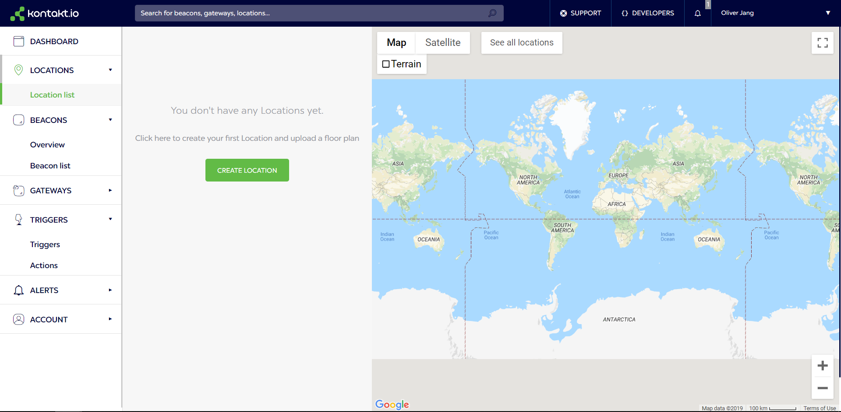

When adding a location, a Name and an Address are required, and description can be optionally entered. Once entered click on the ‘Next Step’ button to create the location.

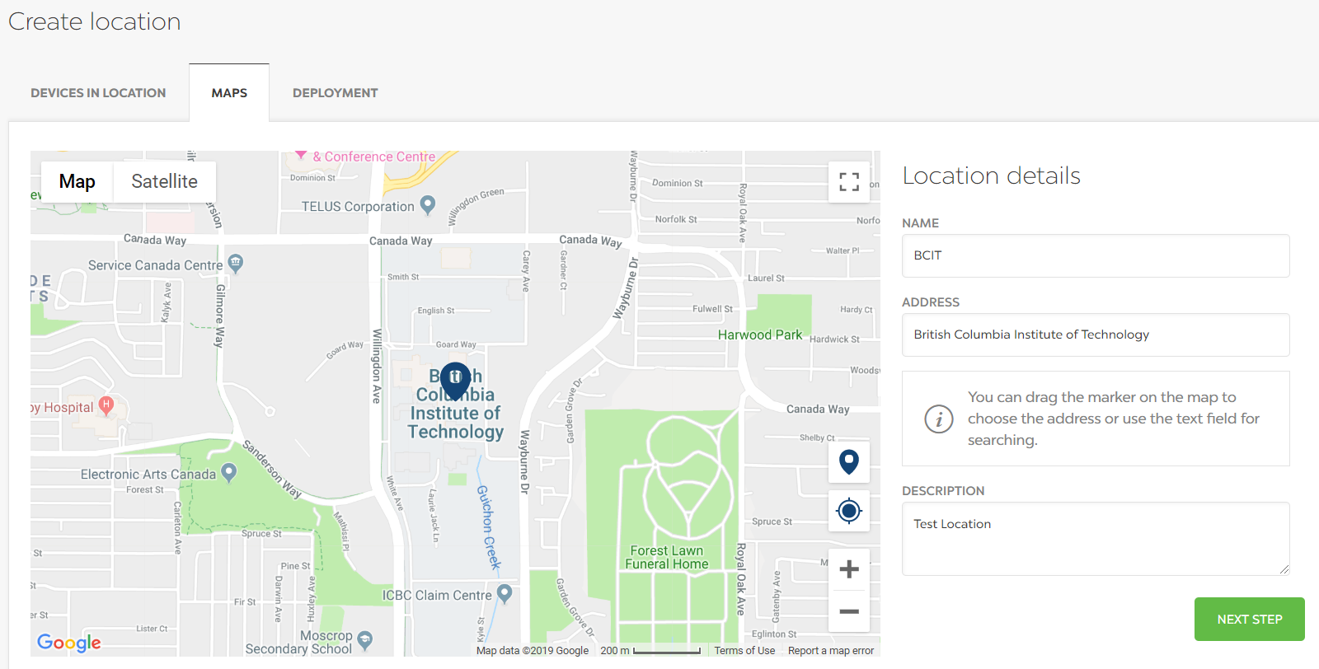

### Deleting a Location:

Locations can be deleted from the location menu by clicking on the ‘Garbage Can’ icon that shows up when you hover your mouse over a row and then confirming at the confirmation message.

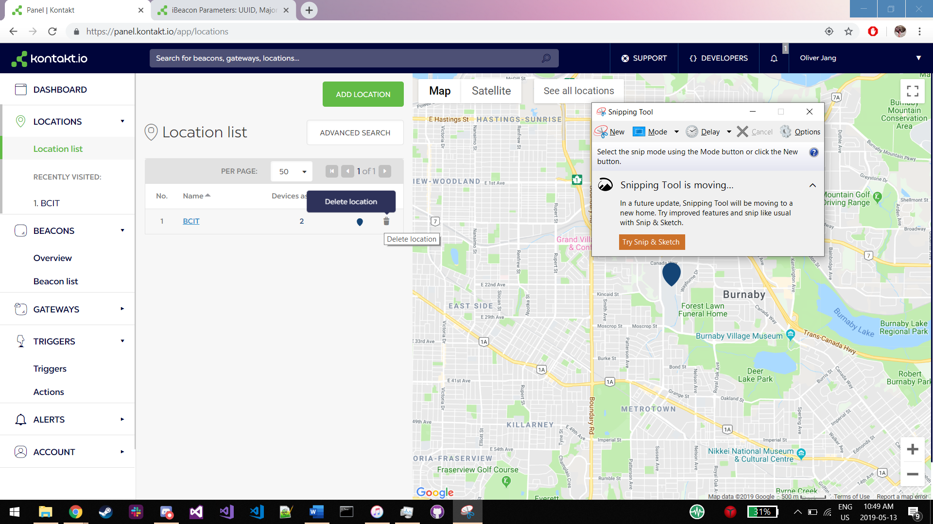

### Adding/Removing Beacons to a Location:

Adding and removing beacons from a location can be done from the Beacon page. By selecting beacons (through the check boxes) the beacons can be assigned or removed from locations through the menu.

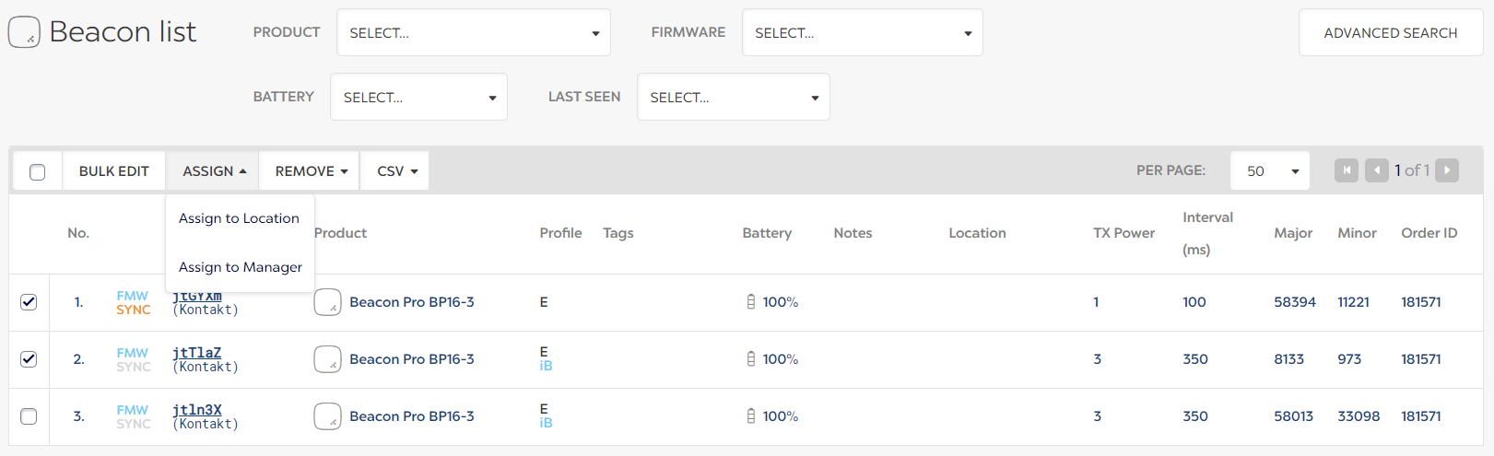

Upon clicking ‘Assign to Location’ or ‘Remove from Location’ confirmation prompts will appear detailing which location to assign to or confirming you would like to remove from its location.

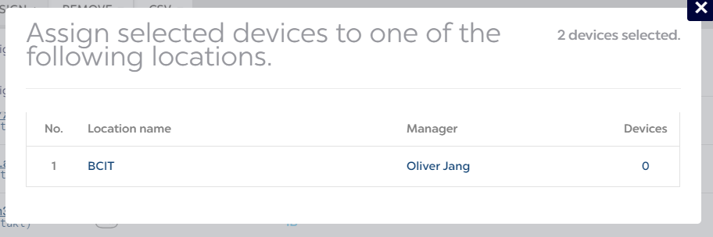

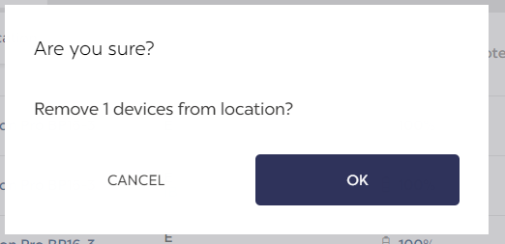

# Kontact.io Mobile App:

The Kontact.io mobile app is used to sync settings onto beacons. Any changes to settings made through the Kontact.io web portal or the app are not applied onto the beacons until they are synced.

Upon opening the app and enabling Bluetooth on your phone, the app will automatically search for nearby beacons. All found beacons will be displayed in the devices tab with small amount of general info.

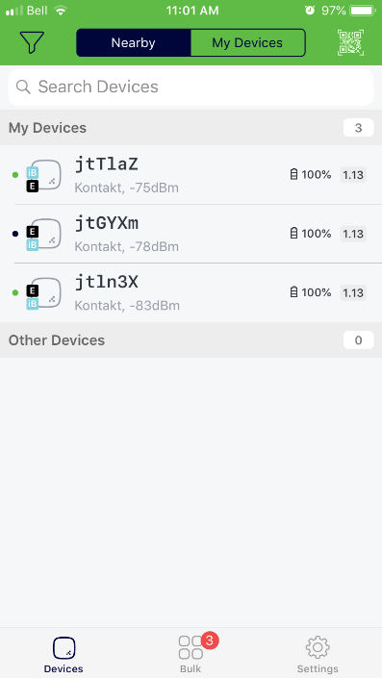

Tapping on any of the beacons will open the device page. This page allows you to configure the beacon (see Kontact.io web section for details on configuring beacons). After doing any configuration on the beacon press the save button to sync your changes onto the beacon.

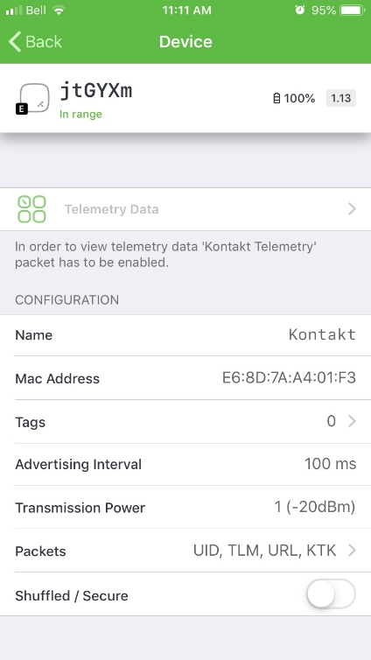 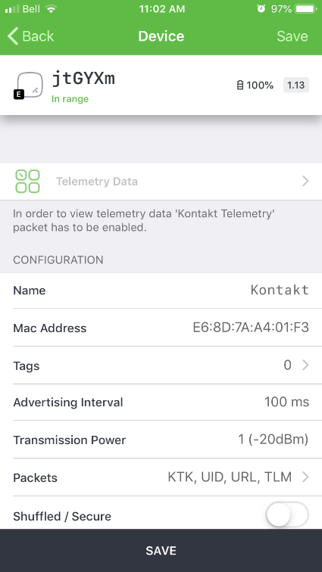

If a beacon’s settings are out of sync with the configured settings in the app, a ‘Pending Configuration’ button will show. Click the button and then confirm by clicking ‘Apply’ to sync with the beacon. This will connect the beacon with the app and apply the settings configured on the app onto the beacon.

